T.C.
DOKUZ EYLÜL UNIVERSITY
MARITIME FACULTY
MARITIME BUSINESS ADMINISTRATION DEPARTMENT
DIPLOMA PROJECT

TITLE OF THE DIPLOMA PROJECT

Name SURNAME

Supervisor
Title Name SURNAME

İZMİR - 2026

DECLARATION

I hereby declare that this diploma project titled “…………………………” has been written by myself by the academic rules and ethical conduct. I also declare that all materials in this study benefited from the mentioned resources in the reference list. I verify all these with honor.

Write Date Here
Name SURNAME

ABSTRACT
Diploma Project Title
Name SURNAME

Write your abstract here.

Keywords: Write 5 Keywords Each Starting With a Capital Letter.

DIPLOMA PROJECT TITLE

CONTENTS
DECLARATION ii
ABSTRACT iii
CONTENTS iv
ABBREVIATIONS vi
LIST OF TABLES vii
LIST OF FIGURES viii
APPENDICES ix
INTRODUCTION 1
CHAPTER ONE 2
ARTIFICIAL INTELLIGENCE 2
1.1. BIRTH OF ARTIFICIAL INTELLIGENCE 2
1.2. TYPES OF ARTIFICIAL INTELLIGENCE 2
1.3. ALAN TURING AND THE TURING TEST 3
1.4. ARTIFICIAL GENERAL INTELLIGENCE 3
1.4.1. Artificial General Intelligence Alignment 3
1.4.2. Transition to Artificial General Intelligence 4
CHAPTER TWO 5
NATURAL LANGUAGE PROCESSING 5
2.1. NATURAL LANGUAGE PROCESSING DEFINITIONS AND BASIC CONCEPTS 5
2.2. DEVELOPMENT OF NATURAL LANGUAGE PROCESSING AND PIONEERING STUDIES 6
2.3. NATURAL LANGUAGE PROCESSING TECHNIQUES 6
CHAPTER THREE 8
TECHNOLOGY OF CHATGPT 8
3.1. TECHNICAL STRUCTURE AND OPERATION OF CHATGPT 8
3.2. PROCESSES BEFORE THE PRE-TRAINED LANGUAGE MODEL 8
3.3. GPT VERSIONS 9
3.3.1. GPT 1 9
3.3.2. GPT 2 11
3.3.3. GPT 3 12
3.3.4. GPT 3.5 12
3.3.5. GPT 3.5 TURBO 12
3.3.6. GPT 4 13
3.3.6.1. Early Version GPT-4 13
3.3.6.2. Latest Version GPT-4 13
3.3.7. GPT-4 TURBO 14
CONCLUSION 19
REFERENCES 20
APPENDICES 22

ABBREVIATIONS

AI Artificial Intelligence
API Application Programming Interface
BERT Bidirectional Encoder Representations from Transformers
BLEU Bilingual Evaluation Understudy
CV Curriculum Vitae
GPT Generative Pre-trained Transformer
Li-Fi Light Fidelity
MR Magnetic Resonance
SA Sentiment Analysis
SEO Search Engine Optimization
TEU Twenty-feet Equivalent Unit
Wi-Fi Wireless Fidelity

LIST OF TABLES

Table 1: Training Data and Parameter Properties of GPT Models-1 16
Table 2: Training Data and Parameter Properties of Models-2 17

LIST OF FIGURES

Figure 1: ChatGPT Enterprise Architecture and Components 7
Figure 2: ChatGPT Model Architecture 10
Figure 3: Squirrel Example 14
Figure 4: Squirrel Example CHATGPT Model Output 15

APPENDICES

APPENDIX 1: OpenAI Charter annex p. 1
APPENDIX 2: European Union Artificial Intelligence Regulation annex p. 2

INTRODUCTION

As one of the most rapidly evolving fields of modern technology with the profoundest impact on human life, artificial intelligence pioneers’ transformations across a wide spectrum, ranging from information processing workflows to social interactions. Through the development of systems exhibiting human-like intelligence and their deployment in various fields, artificial intelligence has come to influence our daily lives and information processing operations. This study aims to comprehensively examine the effects of ChatGPT, a prominent artificial intelligence language model, on human life and information processing.
The foundations of the concept of artificial intelligence were laid in the 1950s with Alan Turing's article 'Computing Machinery and Intelligence' and were further consolidated by the Dartmouth Conference in 1956 (Kopar, 2023). This period marked the beginning of a major wave of research and development in the field of artificial intelligence. Artificial intelligence studies have continued to develop across various categories, gaining significant momentum in recent years, particularly through advancements in natural language processing and deep learning.
In this study, the emergence and historical development of the concept of artificial intelligence will be discussed. Subsequently, natural language processing techniques and the various applications of these techniques will be examined. The founding, development, and work of OpenAI on artificial intelligence models will be detailed, with a specific focus on the ChatGPT series, the evolution of the models, and the technical structure of the technology. Furthermore, the topics of artificial intelligence ethics and safety will be addressed, and the effects of artificial intelligence on human life and information processing workflows will be investigated. Artificial intelligence has opened the doors to a new era in information processing and human-machine interaction and is expected to lead to transformations in numerous fields, ranging from education to health, and from finance to art. In this context, this study aims to shed light on the future by investigating the effects on human life and information processing through an evaluation of the potential and limitations of ChatGPT.

CHAPTER ONE

ARTIFICIAL INTELLIGENCE

BIRTH OF ARTIFICIAL INTELLIGENCE

The foundations of the concept of Artificial Intelligence were first laid during the 'Dartmouth Summer Research Project on Artificial Intelligence,' which took place in the summer of 1956 at Dartmouth College in Hanover, New Hampshire. At this inaugural meeting, organized by John McCarthy, a mathematics professor at Dartmouth College, a group of scientists gathered not merely to honor the past and evaluate existing achievements, but to develop ideas for future artificial intelligence research.
The Dartmouth Conference made an immediate and lasting impact on artificial intelligence research, helping to establish the field as an independent discipline. Its interdisciplinary nature fostered collaboration among researchers from diverse backgrounds and inspired the establishment of prominent artificial intelligence laboratories at institutions such as MIT and Stanford. Furthermore, it had long-term effects, such as the development of certain programming languages and advancements in deep learning techniques. In addition, by opening up discussions on ethical issues, such as the potential for artificial intelligence to surpass human intelligence and the responsibilities of researchers, it increased interest in artificial intelligence and ensured widespread media coverage.

TYPES OF ARTIFICIAL INTELLIGENCE

- Narrow AI: Includes systems like chatbots or facial recognition software. These systems can provide accurate results, but they cannot generalize like humans.
- General Artificial Intelligence: It is a theoretical level of artificial intelligence that has the ability to do any mental task that humans can. AGI is equipped with a wide range of problem-solving and learning abilities.

ALAN TURING AND THE TURING TEST

In 1950, Turing published his paper "Computing Machinery and Intelligence," in which he proposed a test to determine whether machines could think. The Turing Test proposed in this paper involved a human interrogator asking questions to two participants (a human and a machine). The purpose of the interrogator was to determine which participant was the machine, and the purpose of the machine was to convince the interrogator that it was human.

ARTIFICIAL GENERAL INTELLIGENCE

Artificial General Intelligence (AGI) refers to artificial intelligence systems that exhibit human-like intelligence, capable of performing a wide range of tasks across various domains. Unlike narrow AI, which specializes only in specific tasks, AGI is capable of performing a wide range of tasks, including language understanding, mathematical problem-solving, writing code, visual perception, medical diagnosis, and legal analysis. This wide range of capabilities enables AGI to perform close to or above human level in many different areas. With cognitive flexibility, AGI can expand their knowledge and skills by drawing from learning and experiences. With the ability to combine knowledge and skills across different disciplines, AGI can also generate innovative solutions, solve complex problems, and acquire new knowledge. They may interact with human intentions and emotions, demonstrating advanced abilities in aspects such as explainability and shared sense understanding. AGI can use a variety of tools and plan complex tasks. The primary goal of AGI is to become a system that mimics the broad cognitive abilities of human intelligence and can apply these abilities in various tasks (Bubeck et al., 2023).

1.4.1. Artificial General Intelligence Alignment

Alignment refers to the alignment of AI's goals and behaviors with human values and purposes. This is done to ensure that AI systems are safe and beneficial for humanity. The alignment problem encompasses the processes that ensure that the goals of the artificial intelligence system are correctly determined and that the artificial intelligence system adheres to these goals and implements them correctly.

1.4.2. Transition to Artificial General Intelligence

The first step in the preparation process for AGI is to develop increasingly powerful artificial intelligence systems and gain experience by using them in the real world. Instead of AGI quickly incorporating into daily life, a gradual transition process would be healthier. Adapting to the rapid progress that powerful AI will bring will be possible by making this transition gradually. Thus, it will be possible to better adapt to the innovations and changes that artificial intelligence will bring.
In the process of advancing AI security, talents need to be several steps ahead. The best security work is done with the most capable models.

CHAPTER TWO

NATURAL LANGUAGE PROCESSING

Natural Language Processing (NLP) emerges as one of the most exciting and rapidly evolving technology areas of today. This discipline for understanding the complexities and subtleties of human language brings together various fields such as computer science, linguistics, and machine learning. The fundamental concepts and definitions of NLP are critical to understanding this broader field. The following section will focus on the basic definitions and concepts of NLP, examine its historical development and pioneering studies, and detail the techniques commonly used today.

NATURAL LANGUAGE PROCESSING DEFINITIONS AND BASIC CONCEPTS

NLP uses statistical and probabilistic methods to build language models. These models are used to understand word frequencies, phrases, and language structure in the language. NLP automates language processing tasks using machine learning and deep learning algorithms trained on large datasets. These methods learn patterns and relationships in language, improving their capacity to understand and produce language. For example, neural networks and transformer models are used in tasks such as text classification, language model building, and machine translation. NLP examines not only the surface structure of language, but also its semantic and pragmatic dimensions. This allows computers to understand the context of the language and user intent. For example, techniques such as word meaning separation and information extraction address the meaning dimension of language. NLP is used in a wide range of applications. These applications include text mining, sentiment analysis, chatbots, automated summarization, information search, and machine translation. These applications play an important role in many areas, from business to health, from education to entertainment. In this context, NLP is an interdisciplinary field of study that brings together computer science and linguistics to understand the complexities of human language and use this knowledge in various applications.

DEVELOPMENT OF NATURAL LANGUAGE PROCESSING AND PIONEERING STUDIES

NLP was born out of the need for automatic interlingual translation in the 1940s after World War II. The Georgetown Experiment in 1954 made a significant start in this field with its fully automated translation of Russian sentences into English, but the ALPAC report in 1966 showed that a decade of research did not meet expectations. In the 1960s and 1970s, NLP systems relied on complex handwriting rules, and early systems excelled in understanding natural language commands with limited vocabulary. Towards the end of the 1980s, machine learning algorithms revolutionized NLP, bringing statistical and probabilistic methods to the forefront. In this period, IBM Research's achievements in machine translation are remarkable (Tecim & Tarhan, 2021). In the 1990s, probabilistic models became widespread, leading to significant advancements in areas such as information extraction and text summarization. Since the 2000s, the focus has been on unsupervised and semi-supervised learning algorithms, thus increasing the capacity to learn from large datasets. Today, NLP chatbots are widely used in various applications such as language translation, sentiment analysis, and information extraction (Manning, 1999) (Tecim, 2008).

NATURAL LANGUAGE PROCESSING TECHNIQUES

NLP combines linguistics, computer science, and machine learning techniques to analyze the structure and meaning of language.

Figure 1: ChatGPT Enterprise Architecture and Components

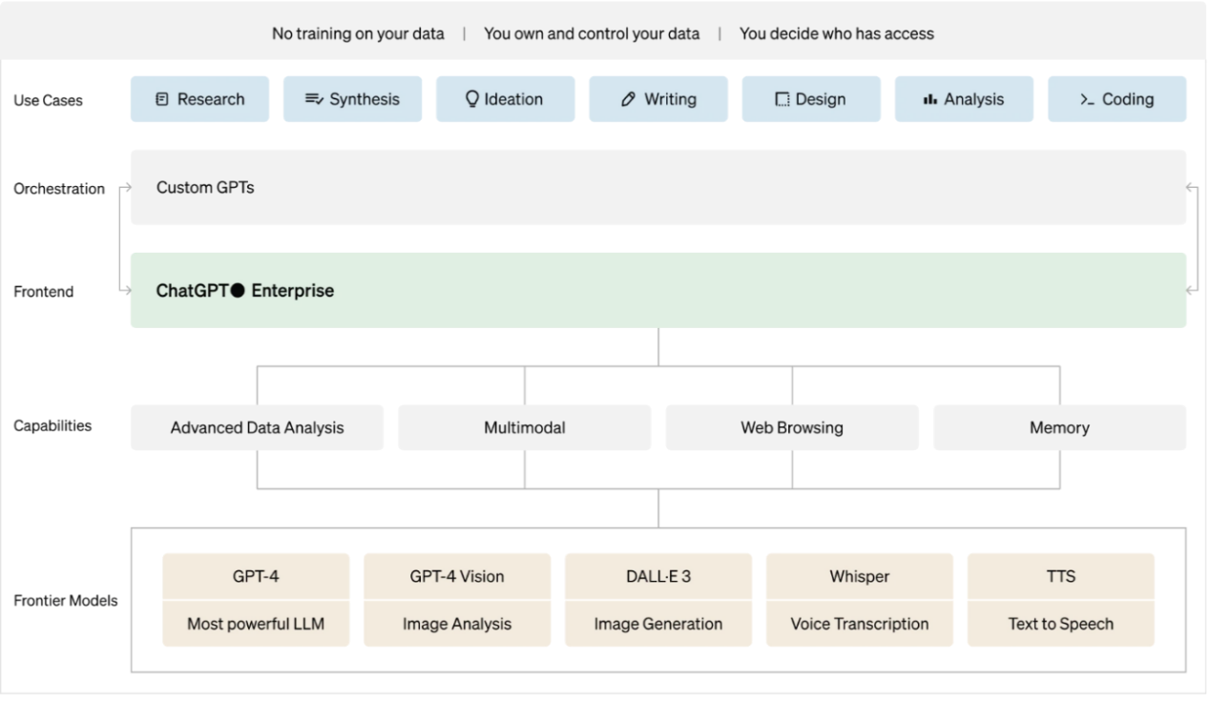
Source: OpenAI, 2024

CHAPTER THREE

TECHNOLOGY OF CHATGPT

This chapter will discuss the technical structure and operation of ChatGPT in detail. The model is built on a generative pre-trained transformer architecture and is trained using human feedback reinforcement learning with human feedback reinforcement learning method. In this way, ChatGPT can interact with users more naturally and effectively and perform various language tasks with high accuracy. The chapter also examines topics such as multimodal learning, previous language modeling methods, versions, and its evolution.

3.1. TECHNICAL STRUCTURE AND OPERATION OF CHATGPT

In the realm of NLP and language modeling, RPE is a significant milestone. In this section, the ÜÖED model versions will be discussed in detail. ChatGPT is a language model trained for text generation designed to guide the structure towards the desired behavior using Reinforcement Learning with human Feedback (OpenAI, 2024) Multimodal learning is a subset of deep learning that deals with the combination and analysis of various types such as text, images, video, audio, and sensor data. By combining the strengths of different modalities (data type), it creates a more complete representation of the data, which leads to better performance in various machine learning tasks.

3.2. PROCESSES BEFORE THE PRE-TRAINED LANGUAGE MODEL

Previously, operations were performed using N-gram models, long-term short-term memory, and other traditional methods.
N-gram models are statistical models that predict the probabilities of sequences of n words within a given text. These models were good at capturing short-distance dependencies but were insufficient at capturing long-distance dependencies.
Long, short-term memory is a special type of recurrent neural network structure and is capable of learning long-term dependencies in successive data. Long short-term memory is designed to solve the problem faced by traditional neural network structure. This model is equipped with additional components such as an entrance door, a forget-me-not door, and an exit door. These gates control the addition of new information to the cell state, the oblivion of existing information, and how it is reflected in the output. It is widely used in tasks such as language modeling, time series forecasting, speech recognition, and translation.
Although these models excelled in certain tasks, their overall performance was limited due to their narrow range of tasks. Transformers offered the opportunity to work more efficiently on large datasets thanks to their parallel computing capabilities. In this way, faster transactions were made and the time was shortened.

3.3. GPT VERSIONS

The GPT model versions developed by OpenAI are described below.

3.3.1. GPT 1

The first language model, GPT-1, announced by OpenAI in 2018, had 117 million parameters. One of GPT-1's strengths was its ability to generate fluid and coherent language when given context to a stimulus v1e. The model was trained on a combination of two datasets: Common Crawl, a large dataset of web pages containing billions of words, and BookCorpus, which houses over 11,000 books of various genres. The use of these diverse datasets enabled GPT-1 to develop powerful language modeling capabilities. GPT-1 was a significant achievement in the field of NLP, but it had certain limitations.
Figure 2 shows the task-based architecture of the GPT-1 model and the details of transformer-based decoders. We can examine the diagram in three main sections.

Figure 2: ChatGPT Model Architecture

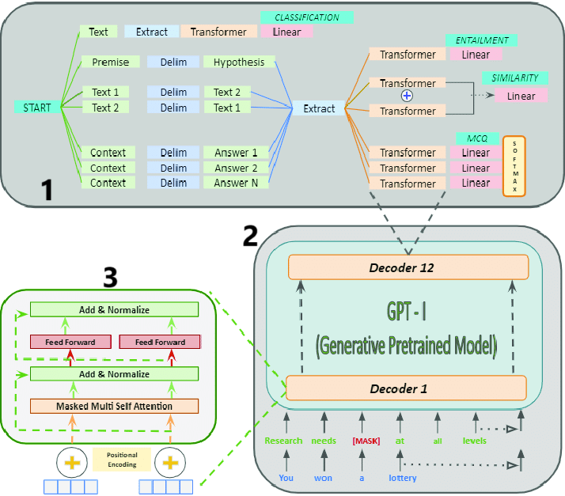
Source: Singh et al, 2021

Part 1 illustrates how the GPT-1 model performs various NLP tasks: Data Preparation (Text, Extract, Delimiters):
- Classification: Premise and hypothesis sentences given as introduction are covered. The model is used to determine the relationship between these two sentences.
- Entailment: Similarly, it is used to determine the logical relationship between two texts.
- Similarity: Evaluates the similarity between two texts.
- MCQ (Multiple Choice Questions): Processes context and answer options and determines the correct answer.
These stages work by processing the data and passing it to the transformer layers and then classifying it over the linear layers.
Part 2 shows the general structure and layers of the GPT-1 model:
Decoder Layers (Decoder 1 - Decoder 12):
- The GPT-1 model consists of 12 decoder layers. These layers process input text, producing meaningful outputs.
- Positional Encoding adds the position information of Text tokens so that the model can learn the sequential information.
- Each decoder layer consists of "Add & Normalize", "Feed Forward", and "Masked Multi-Self Attention" components.
Part 3 shows in detail what happens inside each decoder layer:
- Add & Normalize: The process of normalizing the input entering the layer and adding it to the input takes place.
- Masked Multi-Self Attention: The masked multi-self-attention mechanism allows the model to learn the relationships between tokens.
- Feed Forward: The process of converting representations of each token by applying linear transformations.
These processes are repeated at each layer, allowing the model to produce more sophisticated and meaningful outputs.

3.3.2. GPT 2

Announced in February 2019, the model is 2. GPT-2, which is the version, was released as the successor of GPT-1. GPT-2 is a large-scale unsupervised language model capable of generating coherent paragraphs. The model is simply trained on 40 GB of internet text to predict the next word. Four variants have been developed, with sizes ranging from small (124 million parameters) to large (~1.5 billion parameters).

3.3.3. GPT 3

GPT-3 was first announced on May 28, 2020. It is a model that has been pre-trained on a large text source and can perform various language tasks with high accuracy. With 175 billion parameters, it contains ten times more parameters compared to previous language models. A total of approximately 570 GB of text data was used.

3.3.4. GPT 3.5

A fine-tuned version of the GPT-3 model is an advanced language model that has an update. GPT-3.5 is trained on a larger dataset for longer periods, offering improvements in language understanding and generation capabilities.
Built on top of GPT-3, it is trained on reinforcement learning, which learns from human feedback. This method helps the model follow user instructions more accurately and generate more human-like responses. This improved the model's performance in natural language understanding tasks.

3.3.5. GPT 3.5 TURBO

GPT-3.5 Turbo is faster and offers lower latency than the original GPT-3.5 model, making it ideal for real-time applications. This model supports parallel function calls, allowing for quick response times and increasing the capacity to handle longer texts. It is widely used, especially in chat-based applications, making user interactions more efficient. GPT-3.5 Turbo offers the possibility of fine-tuning. This allows users to optimize the model's performance for specific usage scenarios.

3.3.6. GPT 4

Announced on March 14, 2023, GPT-4, which was developed after its predecessor, the free GPT-3.5, has shown significant differences thanks to its more advanced structure.
With a monthly usage fee of $20 and a certain usage limit, this new version offers users a more comprehensive and impressive experience. GPT-4 allows 40 message inputs in 3 hours, and once this limit is exceeded, a certain amount of time must pass before users can reuse them.
"I am an AI language model and cannot provide private information about individuals or their personal lives, including who are the people who are getting married. If you're looking for information about a specific couple or celebrity wedding, please provide their names or more, and I'll try to assist you."

3.3.6.1. Early Version GPT-4

The model provides a direct response to the user by providing detailed information about the people getting married. However, sharing such personal information can be ethical and privacy risky.

3.3.6.2. Latest Version GPT-4

The model informs the user by providing a more general response, avoiding sharing personal information. This demonstrates the model's evolution in protecting users' privacy and adhering to ethical standards.
GPT-4, while delivering impressive results, is devoid of several shortcomings and bugs. The model may produce inaccurate output in some cases and may perform lower than expected in certain scenarios. Additionally, while GPT-4 has brought significant advancements in the field of artificial intelligence and language processing, it does have some limitations. For example, it can produce false or misleading information. This requires users to verify the information provided by the model. It may be insufficient in the complex tasks given. For example, he can make mistakes in multi-step math problems. Additionally, it can be used by malicious actors to generate fake news or harmful software, posing serious security risks.

3.3.7. GPT-4 TURBO

GPT-4 Turbo is an improved version of OpenAI's GPT-4 model, offering several improvements and new features. GPT-4 Turbo can handle longer texts with 128k context windows (equivalent to 300 pages of text in a single prompt), outperforming GPT-4 in more complex interactions. The maximum number of output tokens is 4096. Furthermore, it can handle both text and image inputs thanks to its multimodal capabilities; This allows it to complete tasks such as automatic title generation and visual content analysis.

Figure 3: Squirrel Example

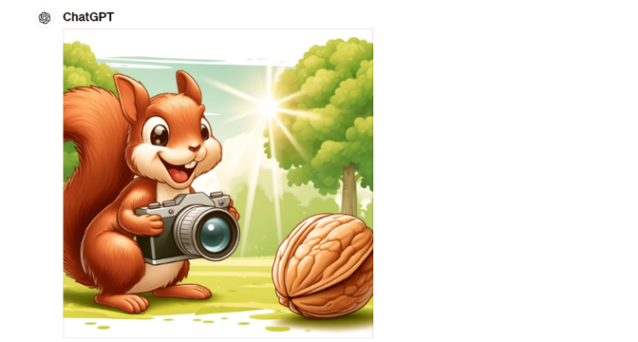
Source: Generated by Author and OpenAI.

Figure 4: Squirrel Example CHATGPT Model Output

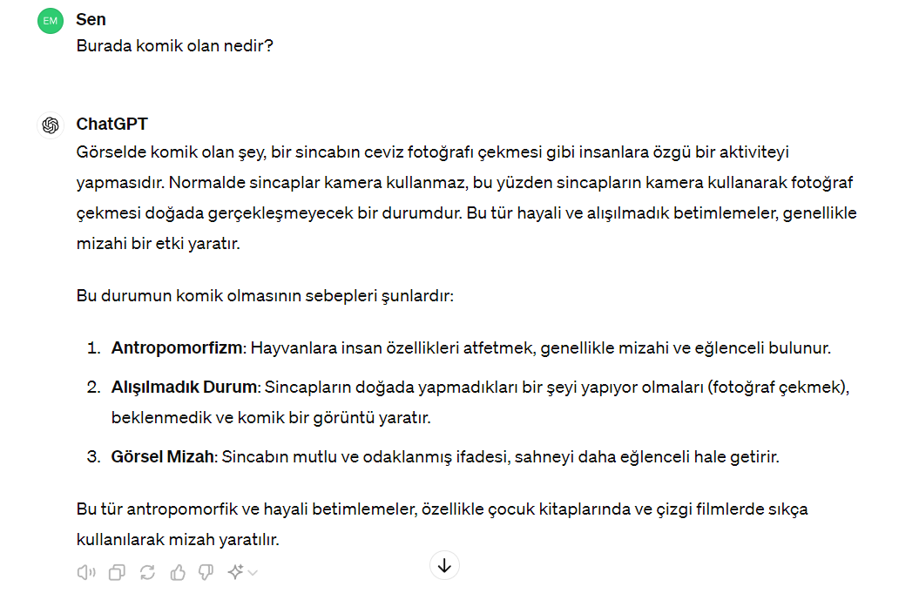
Source: Generated by Author and OpenAI.

The ChatGpt-4o version has shown that it has the capacity to perceive the message by analyzing photos. For example, for an image of a squirrel taking a photo of a walnut, when asked what is funny here;
He stated that the squirrel took a photo of the walnut, but this would be human behavior and that taking a photo of the walnut exhibited unexpected behavior, so this squirrel image would be described as funny. Here, Gpt-4o has made a comprehensive interpretation by conducting multiple analyses. First, he analyzed the image, classified the objects in it and defined what they were. In addition, he evaluated the properties of the defined objects and interpreted how they would behave and by connecting them with other interacting concepts. In addition, he made a comparison according to the general expectation by analyzing what should happen and the situation in the image. In the end, he was able to interpret all this and make an emotional comment by saying that it is funny for a squirrel to take a photo of a walnut instead of eating it.

Table 1: Training Data and Parameter Properties of GPT Models-1
Model | Release Date | Training Data | Parameters | Max Queue Length
GPT-1 | June 2018 | BooksCorpus | 117 million | 512
GPT-2 | February 2019 | WebText dataset with 8 million web pages | 1,5 billion | 1024
GPT-3 | June 2020 | Common Crawl, WebText2, Books1, Books2, Wikipedia | 175 billion | 4096

Source: Generated by Author

This shows the compression efficiency of the new specifier. Representing the same amount of information with fewer tokens improves the overall efficiency of the model and ensures less data transmission during transmission. This provides a significant speed advantage, especially in data transfers over the network. This means less computational power, time, and energy wasted during both training and inference. The low number of tokens allows for a smaller footprint and more efficient operation.
The model's ability to process inputs from different modalities such as text, images, and audio more effectively enables more natural and human-like communication, increases its ability to provide multilingual support, and improves the model's performance in various languages. OpenAI has subjected the GPT-4o model to a comprehensive external attack test with more than 70 external experts in areas such as social psychology, bias and justice, and misleading information to identify and mitigate the risks posed or increased by the newly added modalities. Acknowledging that voice modalities carry various new risks, the company states that efforts to reduce them will continue as risks are discovered.
Table 2 examines the vision understanding performances of various models in different evaluation sets are compared. All opinion evaluations are 0-shot. The GPT-4o model is the highest performance overall. GPT-4T, which came next, overtook Claude Opus and took second place. Gemini models, which are generally lower performers, are in last place. With GPT-4o, a single new model was developed that was trained from start to finish on text, images, and audio, meaning that all inputs and outputs were processed by the same neural network. Thus, it became able to respond to voice inputs in as little as 232 milliseconds (0.232 seconds), with an average of 320 milliseconds (0.32 seconds). In this way, the model was able to approach very close to human response. OpenAI states that since GPT-4 o is the first version to combine all of these modalities, they are still at the beginning of the road in exploring what the model can do and its limitations.

Table 2: Training Data and Parameter Properties of Models-2
Model | Release Date | Training Data | Parameters | Max Queue Length
GPT-1 | June 2018 | BooksCorpus | 117 million | 512
GPT-2 | February 2019 | WebText dataset with 8 million web pages | 1,5 billion | 1024
GPT-3 | June 2020 | Common Crawl, WebText2, Books1, Books2, Wikipedia | 175 billion | 4096
GPT-3.5 | March 2022 | Similar to GPT-3 dataset, no exact information | 175 billion (approximate) | 4096
GPT-4 | March 2023 | Internet data, licensed data sources, human feedback (RLHF) | No exact information, but larger | 32,768
GPT-4 Turbo | November 2023 | Similar to GPT-4 dataset, no exact information | No exact information, but larger | 128 000
GPT-4o | May 2024 | Similar to GPT-4 dataset, no exact information | No exact information, but larger | 128 000

Source: Generated by Author

Figure 5: Dall-E Visual Outputs


Source: Generated by Author

Canva: It is a platform that offers a wide range of services for various design needs. While impressive content can be created for social media posts; It provides the opportunity to design eye-catching posters and flyers for events, campaigns or announcements. Additionally, personalized cards and invitations can be prepared for special occasions such as birthdays, weddings, and New Year's Eve. Professional presentations can be created for business meetings, school projects, or special events. It helps in business or brand representation with unique logos and brand identity designs. It offers graphic solutions for blog posts, web pages, or digital marketing materials. It can prepare professional-looking documents, reports, and resumes, aiding in effective marketing with brochures, catalogs, and advertising materials.

CONCLUSION

This diploma project comprehensively examined the effects of artificial intelligence language models, and ChatGPT in particular, on human life and information processing processes. Starting from the historical development of artificial intelligence, a wide range of topics such as natural language processing techniques, OpenAI's projects, and artificial intelligence ethics and safety are detailed.
………………

REFERENCES

Akkaş, M. A. (2018). Terahertz technology applications and electromagnetic modelling of terahertz waves for wireless communication. Afyon Kocatepe University Journal of Sciences and Engineering, 18(1), 190–200. https://doi.org/10.5578/fmbd.66681
Alameddine, C. W., Schmidt, V. R., & Haoran, A. (2024). Tokenization is more than compression. ar5iv. https://ar5iv.labs.arxiv.org/html/2402.18376
Ali, F. (2023, April 11). GPT-1 to GPT-4: Each of OpenAI’s GPT models explained and compared. MUO. https://www.makeuseof.com/gpt-models-explained-and-compared/
Altman, S. (2023, February 24). Planning for AGI and beyond. OpenAI. https://openai.com/index/planning-for-agi-and-beyond/
Altunışık, R., Çoşkun, R., Yıldırım, E., & Bayraktaroğlu, S. (2001). Sosyal bilimlerde araştırma yöntemleri. Sakarya Kitabevi.
Bubeck, S., Chandrasekaran, V., Eldan, R., Gehrke, J., Horvitz, E., Kamar, E., & Lee, P. (2023). Sparks of artificial general intelligence: Early experiments with GPT-4. arXiv. https://doi.org/10.48550/arXiv.2303.12712
Crowe, S. (2024, January 19). BMW testing Figure 01 humanoid at Spartanburg automotive plant. The Robot Report. https://www.therobotreport.com/bmw-testing-figure-01-humanoid-spartanburg-automotive-plant/
Dilek, G. Ö. (2019). Yapay zekanın etik gerçekliği. Ankara Uluslararası Sosyal Bilimler Dergisi, 2(4), 47–59.
Efe, A. (2021). Yapay zekâ risklerinin etik yönünden değerlendirilmesi. Bilgi ve İletişim Teknolojileri Dergisi, 3(1), 1–24.
Kopar, E. (2023, June 19). Yapay zekanın tarihçesi ve gelişimi. Branding Türkiye. https://www.brandingturkiye.com/yapay-zekanin-tarihcesi-ve-gelisimi/
Manning, C. D. (1999). Foundations of statistical natural language processing. MIT Press. http://archive.org/details/foundationsofsta0000mann
OpenAI. (2024). About. https://openai.com/about/
Singh, S., & Mahmood, A. (2021). The NLP cookbook: Modern recipes for transformer based deep learning architectures. IEEE Access, 9, 68675–68702. https://doi.org/10.1109/ACCESS.2021.3077350
Uçar, A. (2024, March). Türkiye’nin dijital dönüşüm hamlesi. Platin Dergisi.

APPENDICES

APPENDIX 1: OpenAI Charter

APPENDIX 2: European Union Artificial Intelligence Regulation

